Body Scan Meditation
Release Tension with This Targeted Meditation Technique
By
Elizabeth Scott, MS

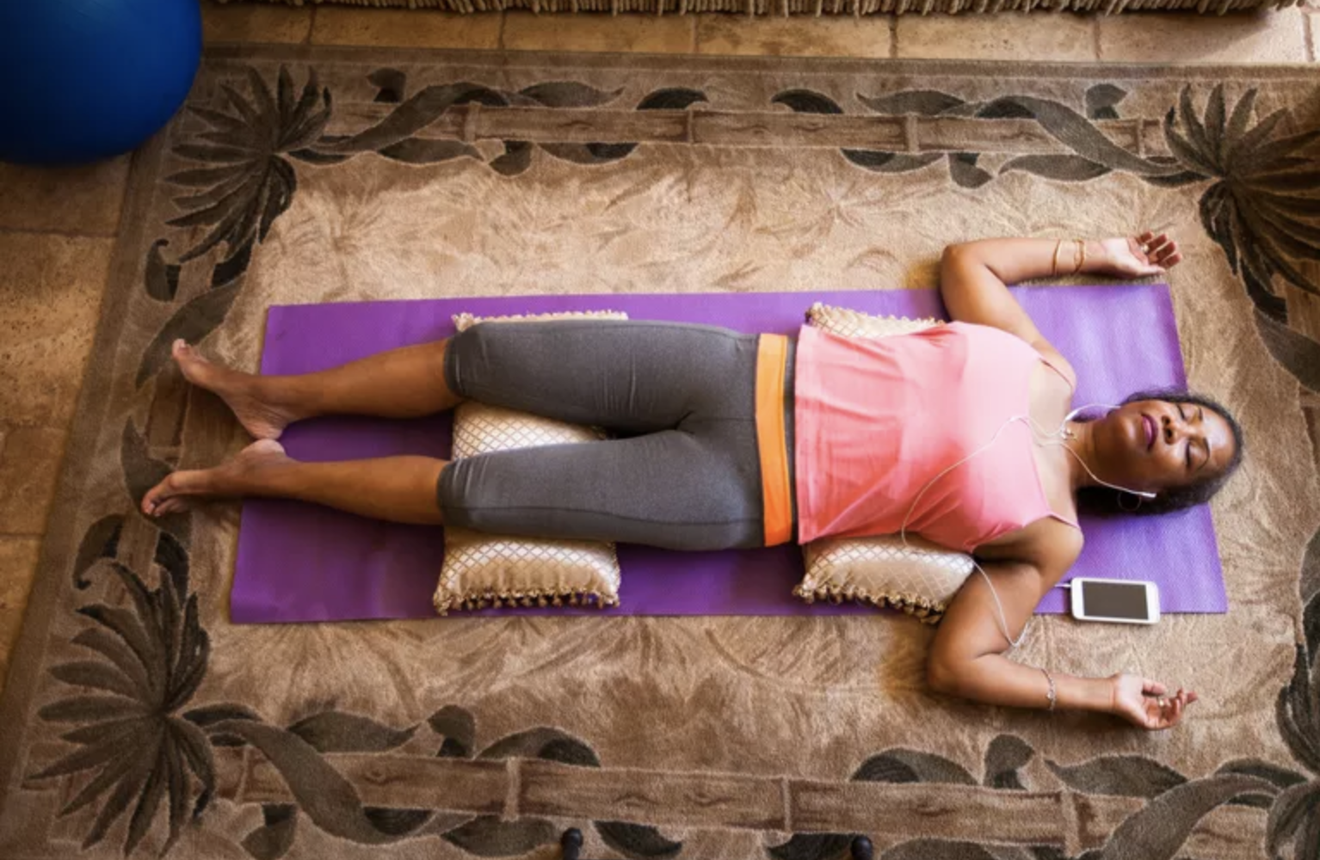
Updated on March 06, 2020

Sometimes you can be so caught up in your stress, that you don't realize that the physical discomfort you're experiencing—such as headaches, back and shoulder pain, and tense muscles—is connected to your emotional state.

Body scan meditation is a good way to release tension you might not even realize you're experiencing. Body scanning involves paying attention to parts of the body and bodily sensations in a gradual sequence from feet to head.

By mentally scanning yourself, you bring awareness to every single part of your body, noticing any aches, pains, tension, or general discomfort. The goal is not to relieve the pain completely, but to get to know it and learn from it so you can better manage it.

Benefits of a Regular Practice
Best when performed daily (or even several times a day), practicing body scan meditation is associated with many mental and physical health benefits. Research shows that stress reduction is one of the primary benefits of body scan meditation, which in turn can have physical benefits including reduced inflammation, fatigue, and insomnia.¹﻿
In this way, this body scanning works to break the cycle of physical and psychological tension that can feed on itself. As a result, the body scan meditation is a very useful and effective meditation that can help you to return to and maintain a relaxed state when you become too tense.
How to Practice Body Scan Meditation
As with all forms of meditation, doing a body scan is meant to be simple. Below are some instructions to get you started.
- Get comfortable. Lying down is preferable, particularly if you're doing a body scan meditation before you fall asleep. If that's not possible or comfortable, sitting comfortably is also an option.
- Take a few deep breaths. Let your breathing slow down, and start breathing from your belly instead of from your chest, letting your abdomen expand and contract with each breath. If you find your shoulders rising and falling with each breath, focus more on breathing from your belly, as though a balloon is inflating and deflating in your abdomen with each breath.
- Bring awareness to your feet. Now slowly bring your attention down to your feet. Begin observing sensations in your feet. If you notice pain, acknowledge it and any thoughts or emotions that accompany it, and gently breathe through it.
- Breathe into the tension. If you notice any uncomfortable sensations, focus your attention on them. Breathe into them, and see what happens. Visualize the tension leaving your body through your breath and evaporating into the air. Move on when you feel ready.
- Scan your entire body. Continue this practice with each area of your body, gradually moving up through your feet until you reach the top of your head. Notice how you feel and where you're holding your stress. If there's any tightness, pain, or pressure, continue to breathe into any tightness, pain, or pressure you're feeling. This can help you release tension in your body now, and be more aware of it in the future so you can release it then, too.
Tips
- Practice this body scan meditation anytime you feel stress or several times throughout the day as a regular practice.
- If you don't have a lot of time, you can do an abbreviated version of this body scan meditation by just sitting and noticing any place in your body that you're carrying tension, rather than moving from part to part. This will become easier the more you practice the body scan meditation.
- The body scan meditation can promote body awareness, stress awareness, and relaxation. Practice it often. You can also try progressive muscle relaxation, breathing exercises, or visualization exercises for releasing stress and tension in your body.

Black DS, O’Reilly GA, Olmstead R, Breen EC, Irwin MR. Mindfulness meditation and
improvement in sleep quality and daytime impairment among older adults with sleep disturbances: A randomized clinical trial. JAMA Intern Med. 2015;175(4):494-501. doi:10.1001/jamainternmed.2014.8081

Manzoni GM, Pagnini F, Castelnuovo G, Molinari E. Relaxation training for anxiety: a ten-years
systematic review with meta-analysis. BMC Psychiatry. 2008;8:41. doi: 10.1186/1471-244X-8-41

